**Implementation Plan**

1. Install XAMPP with the following guide: <https://www.wikihow.com/Install-XAMPP-for-Windows>.
2. Ensure XAMPP is running (guide show you how to run it).
3. 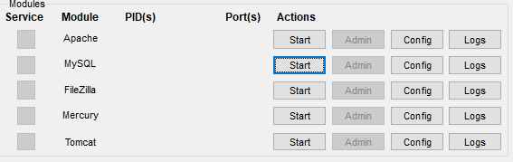Click the start buttons to the right of Apache and MySQL to start them (shown below).
4. Click on this link while pressing the Ctrl key on your keyboard: [SuperSightings](https://drive.google.com/file/d/1Fw9CnuhJKCN6ja_zxZSTkFE-rrWDwf1x/view?usp=sharing)
5. 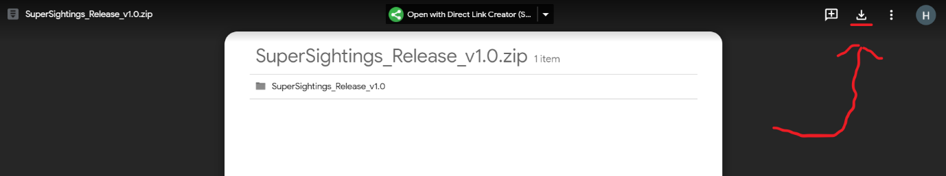Click the download button on the top right (shown below).
6. 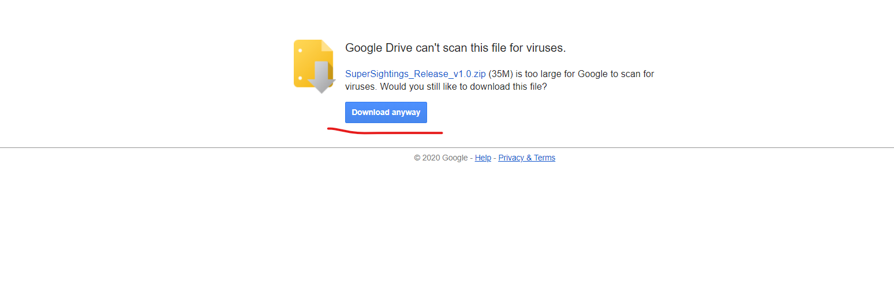Click on download anyway (show below).
7. Go to directory to which the file (SuperSightings_Release_v1.0.zip) was downloaded to – your ‘Downloads’ folder is the default.
   1. Right click the file and click cut.
   2. Go to your documents.
   3. Right-click in the folder and select “New Folder” – call it “SuperSightings_Releases”. Double click on it to enter it.
   4. Right click in the folder and click paste.
8. Right click on the pasted zip file, and click extract all.
9. On the pop-up menu, ensure the box to the left of ‘Show extracted files when complete’ is unchecked – if it is checked, click it to uncheck it.
   1. It is unchecked if there is no tick in it.
10. Click the ‘Extract’ button near the bottom right of the menu that has popped up, leaving everything else at the default.
11. Delete the zip file once extraction is complete, by right clicking on it and clicking delete.
    1. Click on the search icon near the bottom left of your Windows taskbar.
    2. Type ‘recycle bin’ and press enter.
    3. Find and right click ‘SuperSightings_Release_v1.0.zip’, then click delete in the pop-up menu.
12. Double click on the ‘SuperSightings_Release_v1.0’ folder that has been extracted.
13. Go back to XAMMP.
    1. Click on the “Admin” button to the right of MySQL.
    2. 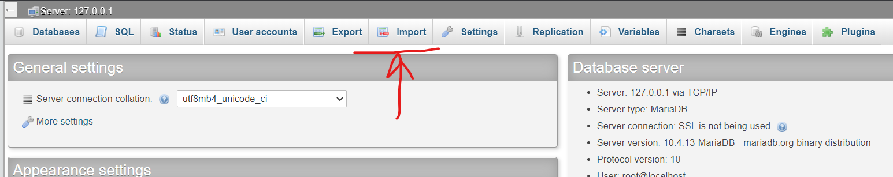A page should open on your default browser. Once it loads, click on the “Import” button (shown below)
    3. Click the “Choose File” button.
    4. On the pop-up window, go to your document -> SupeSightings_Releases -> SuperSightings_Release_v1.0
    5. Double click “SuperHeroSightings.sql”
    6. Go to the bottom of the page (scroll down if necessary) and click on the “Go” button.
    7. Wait for the execution to complete. Once it has completed, you should see this near the top of the page:
    8. Now go back to your “SuperSightings_Release_v1.0” folder.
14. Click on the button with the text ‘File’ in it at the top left of the Windows Explorer window.
15. Click ‘Open Windows PowerShell’.
16. Type or paste “java -jar .\supersightings-1.0.0.jar” (without quotes) into the PowerShell window that has opened.
17. Press enter. The web service should run.
18. If you don’t have Google Chrome, install it here with this guide: <https://support.google.com/chrome/answer/95346?co=GENIE.Platform%3DDesktop&hl=en&oco=0>
19. Start Google Chrome
20. Type <http://localhost:8080> (or copy and paste it) into the chrome search bar, and press enter. This should lead you to the home page of the site.
21. You may now reference the Release Plan included as an attachment to the same email this Implementation Plan is included in, to find out about the features of this application and how to use them.